Herring River Restoration Project Robert Byrnes

Tittle: Comparing and contrasting a dike limited estuary vs. an open tidal flow system

Part 1 Rapid Transect method for comparing Flora and Fauna

Grade Levels
9-12

Main Concepts and Objectives

To understand the relationship between social, civic and scientific components of environmental action to restore a degraded salt marsh.

To use scientific study and data collection to better understand the complexity of real world environmental problems.

To experience both qualitative and quantitative methods in the field to build or contribute to a long term dataset.

To use scientific tools (GPS, maps, CBL, water test kits, laptop computer) to collect and process field data (chemical, physical and biological).

To understand restoration ecology by participating in a project with environmental professionals.

To get hands-on experience in conducting environmental fieldwork.
Estuary Principles Addressed

Principle 2: Estuaries are dynamic ecosystems with tremendous variability within and between them in physical, chemical, and biological components.

Estuaries can also change quickly, within hours or days. They are constantly shaped by water flowing from uplands as well as tidal cycles moving and mixing of fresh and salt water within the estuary. They can be dramatically changed by single, severe events such as a hurricane or the building of a levee.

Principle 4: Ongoing research and monitoring is needed to increase our understanding of estuaries and to improve our ability to protect and sustain them.

Since estuaries incorporate many interacting factors and conditions, research investigations must be carefully designed and results must be considered in context.

Principle 6: Human activities can impact estuaries by degrading water quality or altering habitats; therefore, we are responsible for making decisions to protect and maintain the health of estuaries.
- Human activities within an estuary system, its watershed, and in distant areas impact the biological, chemical, and physical components of estuaries. In particular, land use changes within an estuary’s watershed can change erosion and subsequent sedimentation rates within the estuary, affecting water clarity or bottom substrate.

MA State Biology Standards addressed

6.3 Identify the factors in an ecosystem that influence fluctuations in population size.

6.4 Analyze changes in an ecosystem resulting from natural causes, changes in climate, human activity, or introduction of non-native species.

Essential Questions

- Does the change in elevation in a brackish salt marsh affect the distribution of marsh plant and animal species?
- How does diversity change over an elevation gradient in the marsh?
- How does diversity differ between a tidally restricted vs. an open estuary?
- What changes occur over time as a result of the Herring River Restoration Project (long term)?

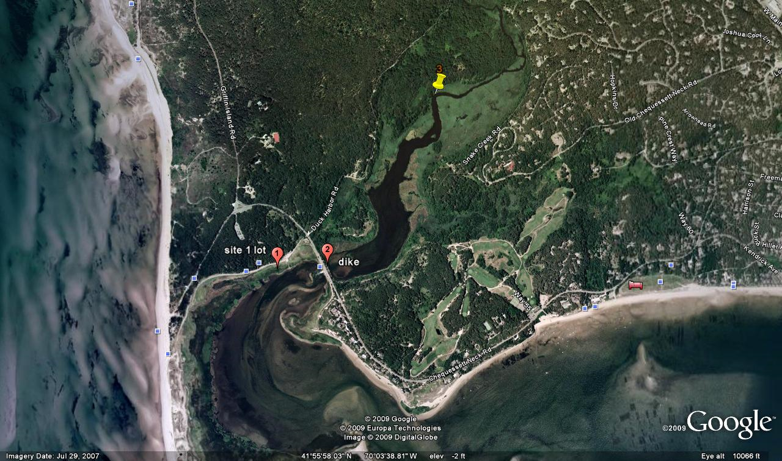
Herring River study area, Wellfleet, MA

Introduction
Wetlands have many values. The stems and leaves of wetland plants trap eroded soil washing from the land and absorb the energy of storm waters. Nutrients that might over enrich the waterways are trapped and used by wetland plants for growth. When these plants die, they enrich the waterways with decaying matter called detritus, a vital food source for microscopic organisms near the base of the food chain. Countless aquatic animals find food and shelter in wetlands including juveniles of many commercially valuable fishes, such as striped bass, and crustaceans, such as crabs and lobsters. An array of wading birds, song birds, waterfowl and birds of prey are attracted to wetlands for food and nest sites. Salt marshes are among the most productive natural plant communities on Earth.

Historically, wetlands have been devalued and vilified by humanity. Blamed as sources of insect pests, they were ditched and drained. Often close to dredging operations, they were covered with dredge spoil. Considered inconvenient barriers between humans and waterways, they were dredged or regulated by dikes in some places and filled in others for the construction of marinas and waterfront homes.

“One hundred years ago in Wellfleet, Massachusetts, Town officials decided to build a dike at the mouth of the Herring River. At the time, the river was the lifeblood of one the largest and most productive coastal wetland systems in New England. But during that era the immense benefits and values of wetlands were ignored and the desire to “…exterminate the mosquito pest…” and “…drain the marshes so they may be brought into valuable land…”led to the construction of a dike at Chequessett Neck Road in order to “…exclude the sea” (report of Whitman and Howard on Proposed Dike at Herring River, 1906).” (Herring River restoration pamphlet)

“During the ensuing decades, the vital role of wetlands has been widely recognized. Wetlands are protected by strong laws and many government agencies and non-government organizations are actively involved in efforts to restore and improve the ecological health of wetlands damaged by past human activity. New England’s largest and most ambitious project of this kind—the Herring River Restoration Project—presents an exceptional opportunity to turn back the ecological clock.” (Herring River restoration pamphlet)

A transect is a path along which one records and counts what flora and fauna are found in an area. It requires an observer to move along a fixed path to count organisms along the path and, at the same time, obtain the distance of the object from the start of the path line. A transect is a cross section through a natural system. A transect is also a way of sampling populations. A transect line is used for measuring the differences between sampling sites. It is not intended to quantitatively measure a population, but rather the differences between sampling sites. In this case, a rapid transect will be used to qualitatively determine the kinds of plants and animals that live in a particular location, You will be recording observations in several areas from the high water line to low tide along the banks of the Herring River estuary.

In this investigation, we will be contrasting the kinds of plants and animals that occupy the shoreline of an unobstructed vs. a tidal restricted estuary. You will be contributing to a rapid data collection with the other members of your group.
As you proceed across your transect, you should record your results on the data sheet.
First, you should identify the dominant vegetation in each section the transect and record its distance from the high tide starting point.. Each time you encounter a new animal species, collect one and record the number of individuals present in a .5 square meter quadrat taken at specific intervals (see procedure for details).

After data collection and observation along your transect, the data will be shared with the other investigators. When data has been shared and recorded, you will repeat the procedure in the next sampling site. At this point you will probably have a pretty good idea about what lives in this location and how populations are distributed.

Vegetation Comparison: When the tidal range is reduced, the upstream habitat may no longer be dominated by salt-marsh grasses, but instead may contain less salt-tolerant species such as common reed (Phragmites australis) or freshwater species such as cattails (Typha sp.). In extreme cases, the habitat may evolve into shrub or forested swamp, and the former wetland may be invaded by upland species.
The habitat both upstream and downstream is assessed visually, and any difference in frequency of salt-tolerant and salt-intolerant plant species is recorded on the data sheet using the classification scheme below.

You will construct a transect similar to the illustration
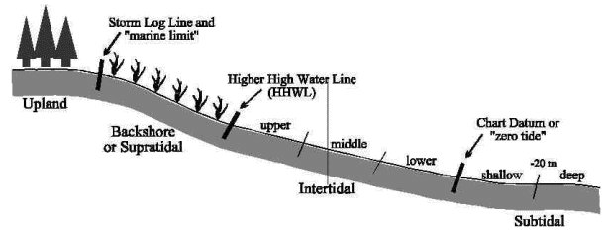

Procedure A:
- Stand at the high tide mark facing the water. Form a line with classmates at arms length parallel to the shore. Pick a visual destination at the shore
- Determine the distance in meters, by pacing from the high tide mark to each vegetation change and to the water’s edge. Record the measurements on your data sheet and identify dominant vegetation in each zone. Begin the survey at the waters edge.
- Make a sketch of the transect features and label them.
  - Mark the point on your sketch where each vegetation zone begins and ends on your transect.
  - Identify and locate the position of plants on the sketch.
  - Identify animals found in the .5M2 quadrats and count the number of individuals found in the quadrat
- Examine live animals and other evidence such as shells present at intervals of two meters along your transect azimuth. View a .5 square meter and estimate the population density (individuals per .5 square meter) for each species. Collect a representative of each organism and place it into your collection bucket. Record census counts on your data sheet.
- Meet with entire group to share data.

Report to group by:
    - describing what animals you found and how many you counted in each quadrat along your transect.
    - What plants were associated with each animal? For example: “marsh snails were found several centimeters from the base of Spartina alterniflora (long form)”.
    - Discus and reasons why this association exists. What does the plant require in order to be present in this place? What factors may limit the plants success? …the animals success?

Procedure B:
- Repeat the procedure in upland, tidally restricted site.

Final report will include:
- An introduction explaining the purpose of the study (part A).
- The transect sketches and data collected and recorded in the tables provided on the data sheet.
- A discussion describing differences between the upland, restricted site vs. the Oceanside open tidal flow site.
- A discussion of information shared and discussed by the group in 5 a, b, and c above.

Indicator species that you will likely find in your transect

Low marsh  Spartina alterniflora (long form) | High marsh low  Spartina alterniflora (short form) | High marsh high  Distichlis spicata  Spartina patens  Juncus gerardii Solidago sempervirens  Limonium nashii  Salicornia europaea  Salicornia virginica  Triglochin arudinacea | Marsh border  Iva frutescens  Baccharis halimifolia  Rosa rugosa  Toxicodendron radicans  Myrica pensylvanica  Panicum virgatum  Typha  Typha latifolia  Dryopteris thelypteris  Typha angustifolia  Althaea officinalis  Scirpus  Scirpus americanus  Juncus canadensis  Scirpus robustus  Cladium mariscoides  Dryopteris thelypteris  Phragmites  Phragmites australis | Shrub Scrub  Myrica gale  Toxicodendron radicans  Myrica pennsylvanica  Clethra alnifolia  Salix spp.

Dune  Ammophila breviligulata  Toxicodendron radicans  Rosa rugosa  Juniperus virginiana | Upland Forest  Pinus rigida  Acer rubrum  Quercus ilicifolia

Sources
Michele Dionne, Ph.D., MAINE.S SALT MARSHES: Their Functions, Values, and Restoration , Wells National Estuarine Research Reserve

Bennett and Rey, An Examination of Marsh Grass Diversity in a Brackish Marsh, 1998.

Herring River Restoration Project Update (Town of Wellfleet MA) www.wellfleetma.org/Public_Documents/WellfleetMA_WebDocs/Brochure.pdf

Safe Harbor Environmental
www.safeharborenv.com/salt-marsh-restoration/

A Protocol for the Long-term Coastal Ecosystem Monitoring Program
at Cape Cod National Seashore, J.Roman
http://science.nature.nps.gov/im/monitor/protocols/caco_marshveg.pdf

Estuaries 101 curriculum, NOAA, NERR, TERC
http:// www.estuaries.gov

